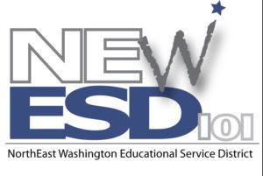
Principal Evaluation
CONSORTIUM

Examples of Evidence & Artifacts

Examples of evidence that could be collected in each of the four domains may include but are
not limited to:

- Leadership in Creating a Shared Vision
- Copy of school improvement plan, building improvement plans/grade level goals
- Building staff development plan
- Staff meeting agenda (addressing vision/mission)
- Weekly school newsletter
- Monthly student recognition
- Local newspaper articles highlighting achievement
- Building wide discipline plans/academic guidelines
- Speak to community in person about vision for learning (number of times)
- Department meeting agendas (grade level meetings, team meetings, etc.)
- District report card/building report - annual report to all community – 3 year comparison
- Parent advisory committee minutes and agenda
- Teaming with community agencies
- Parent volunteer and recognition ceremony

- Instructional Leadership
- Walk-through supervision
- School climate surveys
- Copy of year’s staff development, SIP, plans, etc.
- Faculty meeting agenda (professional and development issues)
- Attendance at state and national conferences
- Building level study teams
- Samples of professional development articles provided to staff
- Information related to opportunities for teachers to observe best practice (both inside and outside discipline)
- Involvement in teacher in-service with teachers
- Data binders and analysis

- Managing The School Environment
- Crisis plan
- School wide discipline plan
- Attendance/tardy procedures/expectations with consistently enforced consequences
- Minutes/agendas of meetings with maintenance staff
- Door monitors, hall monitors, schedules, duties
- Physical plant management plan, walk through

- Managing Fiscal and Human Resources
- Budget management procedures and collaboration
- Evidence of business partnerships to enhance collaboration in community
- Hiring guidelines
- Professional development schedules
- Samples of data used to evaluate and manage school financial, human and time resources.

